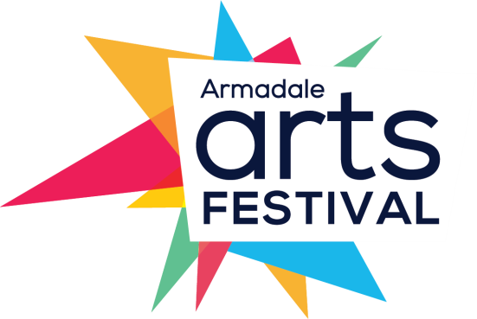

2020 Armadale Arts Festival

Call-out for Community Arts Projects

The City of Armadale is calling for community driven arts projects to be part of the next Armadale Arts Festival, which will be held from 1 to 17 May 2020. We invite your ideas, arts activities and/or events to be part of this festival and leverage the opportunity for additional marketing support and promotion of your group to new audiences.
If you have a concept or project that you’re willing to drive, there’s the potential for City of Armadale assistance in the form of advice, funding and/or support. We recommend thinking of ways to build on the existing activities of your group or to experiment with something new or innovative.
Deadline: 5pm Monday 13 January 2020

In order to put forward your expression of interest for a community arts project to be supported by the City during the 2020 Armadale Arts Festival, you must complete the form over the page and submit it by the due date to City of Armadale Arts Officer Gemma Sidney, via email to GSidney@armadale.wa.gov.au or via post to City of Armadale, Locked Bag 2, Armadale 6992.

Please note: you are also required to submit at least one image, which will be used on the Armadale Arts Festival website and in other promotions if your project goes ahead. Details of this are provided on the form.

We look forward to your group being part of this dynamic arts festival to celebrate the local arts and artists in the Armadale district.
For more information, contact Gemma by phoning 9394 5000 or by sending her an email.

Community Arts Project – Expression of Interest
Please submit your completed form by 5pm Monday 13 January 2020 and send to City of Armadale Arts Officer, Gemma Sidney:
  - Email to GSidney@armadale.wa.gov.au or
  - Post to City of Armadale, Locked Bag 2, Armadale 6992

Your name
Your address |  |  | Your suburb
Your email address
Your contact number |  | (H) | (M)

Your group’s name
Project title
Artform
e.g. visual art, performing arts, music, literature, etc
Project date/s and time/s
Please indicate if these are confirmed
Venue
Please indicate if this is confirmed
Maximum attendance capacity
Cost/ticket prices
If applicable
How tickets can be purchased
e.g. online, door sales, etc
Acknowledgements
If applicable
Partner logos
If contractually required
Short description
Please limit this to 80 words

Full description
Please include any bios as a separate attachment

How will your project engage with the local community?

What’s new or innovative about your project?
This does not have to be a new idea in itself; it may just be new or innovative to your group. Keep in mind the project should be achievable, and ideally in line with the group’s principles

What resources will your project require?

What support are you requesting from the City of Armadale?

Details of attachments
You are required to submit at least one image, which will be used on the Armadale Arts Festival website and in other promotions if your project goes ahead. The image/s should be hi-res (i.e. at least 300dpi or 1MB). You can also attach the bio/s of key group members or artists involved, or other supporting material as appropriate

